Managing Hiring Processes
Objective
After completing this lesson, you will be able to manage hiring processes in SmartRecruiters.
Hiring Processes
Managing the hiring process is crucial for attracting and securing top talent. SmartRecruiters offers robust tools to customize and automate these processes, ensuring a smooth and efficient experience for both candidates and hiring teams.
Hiring processes in SmartRecruiters provide a structured approach to managing candidates through various stages of recruitment. A hiring process is visible on a job under the Hiring Process tab.
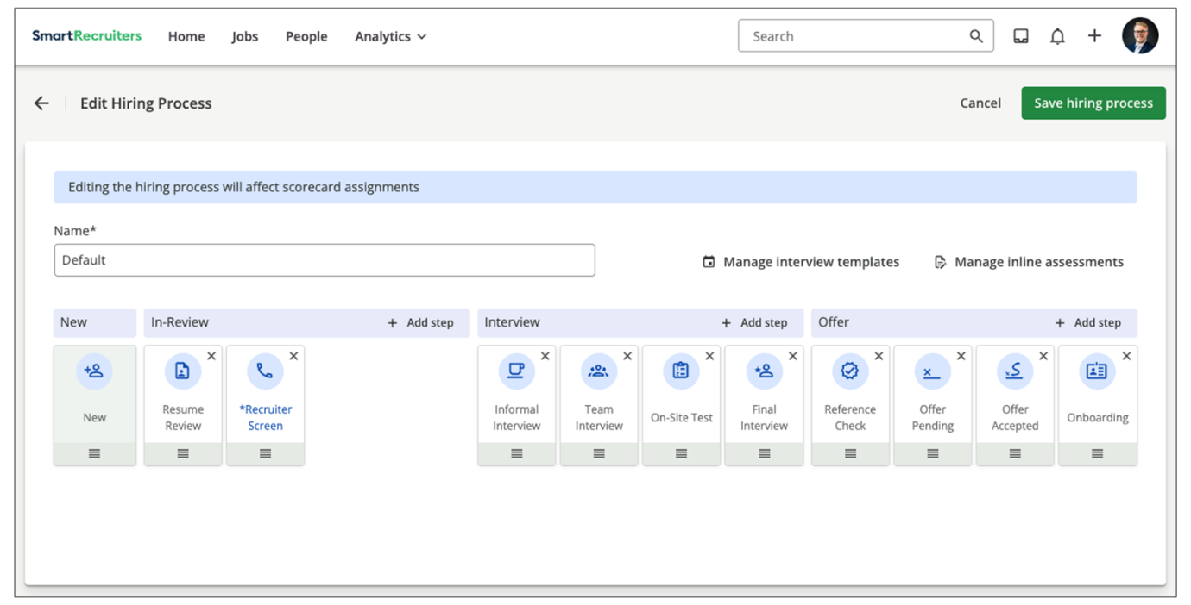
A hiring process dictates the stages (high-level) and steps(including custom steps) a candidate goes through, from initial application to being hired. You can tailor hiring processes to organizational fields, ensuring each job type follows a relevant, specific workflow. A default hiring process is also available for all jobs that don't meet the criteria of any other defined processes. The hiring process is visible on the candidate profile, indicating their current stage in the recruitment journey.
​All SmartRecruiters instances have a default Hiring Process that administrators can customize by adding or removing steps within the main In-Review, Interview, and Offer phases. Once a Hiring Process is configured, hiring team members can move each candidate through steps such as resume review, assessments, and interviews, and analyze the number of candidates at each step over time to identify opportunities for improvement.
Considerations for Managing Hiring Processes
- A maximum of 120 hiring processes can be created.
- You cannot rename standard hiring steps. You can only add, remove, and re-order standard hiring steps.
- You can create custom hiring steps within each of the standard hiring stages (In-Review, Interview, Offer).
Customize the Default Hiring Process
Steps
- Navigate to Settings.
- Select Hiring Process in the Configuration section.
- Select Edit above the hiring process.
- Select Add Step above one of the available categories of statuses to open a list of available steps to add.
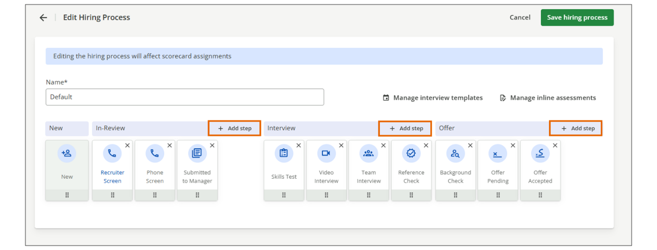
- Choose a step from the list to add.
Alternatively, you can select Add Custom to add a new step.
- To remove a step, select the X icon in the corner of the step tile.
- To reorder a step, select the bottom of the step and drag it to the desired area.
- Select Save Hiring Process.
Create a New Hiring Process
Steps
- Navigate to Settings.
- Select Hiring Process in the Configuration section.
- Select +New Hiring Process.
- Provide the hiring process with a name.
- Select Add Step next to a stage to open a list of available steps for that stage.
Select Add Custom in the list to create a custom step and give it a name.
Hint
Best Practice - To support reporting and analytics, ensure that custom steps added to multiple hiring processes use exactly the same spelling and capitalization.
- Continue to fill each stage with standard or custom steps as desired.
- Select Save.
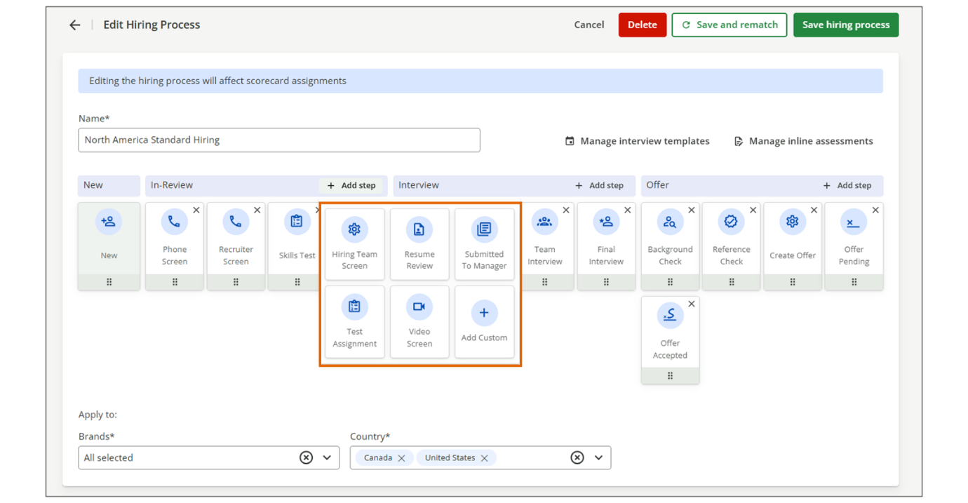
Note
For each stage of a hiring process, it's possible to have up to 15 hiring steps.
Assign a Hiring Process to Jobs
Instead of assigning a custom hiring process to individual jobs, you assign it to specific values in your organizational (Org) fields.
The following rules determine which hiring process is applied.
When someone at your company creates a job and selects Org field values:
- If the selected Org field values match those assigned to a custom hiring process, that hiring process is automatically applied to the job.
- If the selected Org field values do not match any custom hiring process, the default hiring process is applied.
- Only one hiring process can apply to a job. Therefore, if you have (or plan to have) multiple hiring processes, you must ensure that their assigned Org field values do not overlap.
Steps
- Navigate to Settings.
- Select Hiring Process within the Configuration section.
- Select the custom hiring process you would like to assign to jobs.
- In the Apply to section, select the org fields to assign the hiring process to.
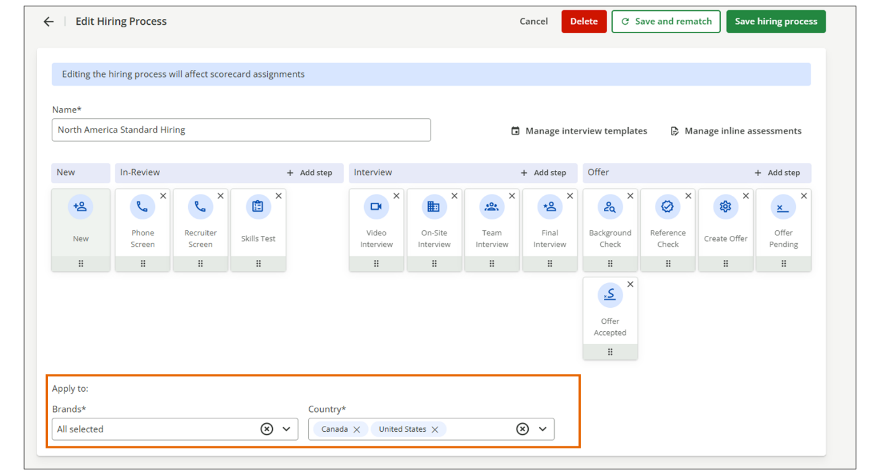
- Select Save Hiring Process.
- If you would like to apply the changes to existing jobs, select Save and Rematch.
Note
When a new process is assigned, and there are steps in the old process that are not also present in the new process, hiring teams will be able see an information icon at the top right corner of that step that notifies them that this is a step from a previous hiring process and candidates in this step should be reassigned as necessary to a valid step in the current hiring process.
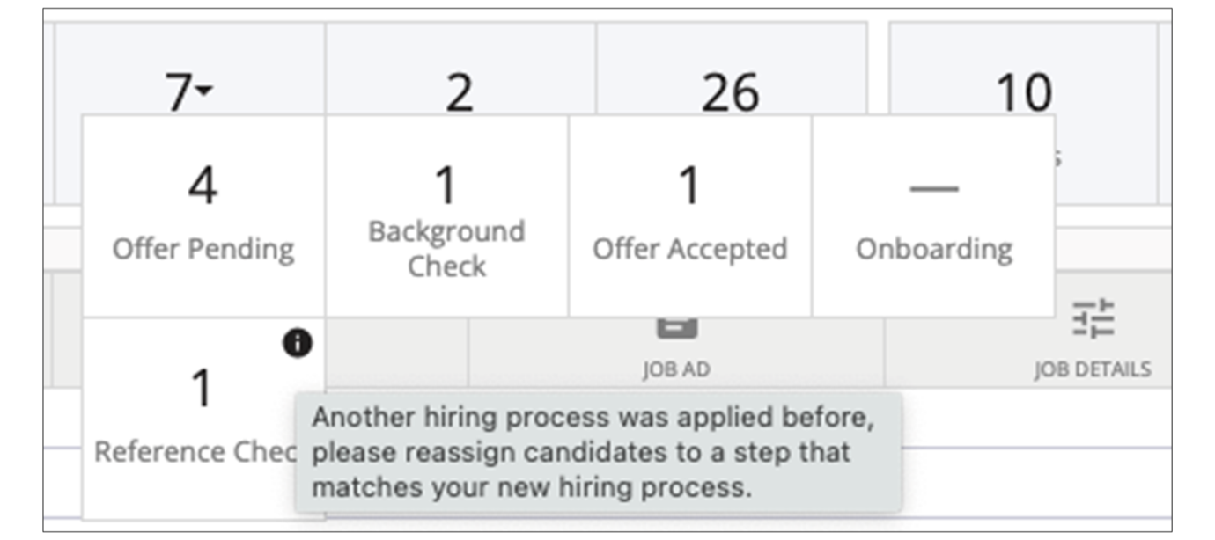
Hiring Process Configuration Features
Workflows, Assessments, and Notifications
Workflows, assessments, and notifications can be added to individual steps in your hiring process. As you click through the stages and steps, a pop-up appears that lets you configure these options for each step.
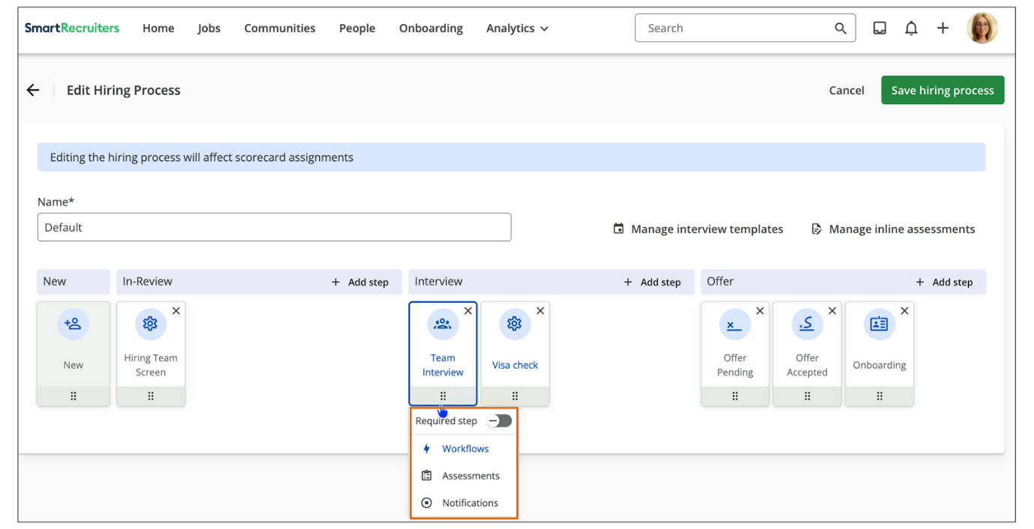
Any step within the In-Review, Interview, or Offer stages can be marked as required. When a step is required, candidates cannot move forward in the hiring process until they reach that step—it cannot be skipped.
Assessment Management
Assessments can be integrated into the hiring process to evaluate candidates' skills and qualifications.
- Adding Assessments: Click on a step and select Assessment.
- Choosing an Assessment Provider: Select the assessment provider from the list (requires integration setup).
- Auto-Trigger: If available, the auto-trigger can be enabled to automatically send the assessment to the candidate once they reach the step.
Assessment Integration
If your organization uses third-party assessment tools, you can integrate them into the hiring process. After setting up the integration in the Apps and Integrations section, you can add in-line assessments to specific steps.
Notifications
For each step, you can enable a notification for the Hiring Manager. When enabled, the Hiring Manager is notified whenever a candidate enters that step.
Use Case Example: Standardizing Company B's Global Hiring Process
Company B is a multinational financial services company with operations across North America, Europe, and Asia. Their recruitment team faces a challenge: different regions and departments are using inconsistent hiring processes, leading to confusion, delayed hires, and poor candidate experiences.
The Challenge:
- Corporate roles require extensive background checks and compliance screenings.
- Entry-level positions in retail banking need quick turnaround times.
- Senior executive hires involve multiple stakeholder interviews and board approvals.
- Regional hiring managers are creating ad-hoc processes, making it impossible to track metrics consistently.
The Solution:
The Global Talent Acquisition (TA) Director works with regional leaders to create three standardized hiring processes.
- Corporate & Compliance Roles Process
  - Assigned to Departments: Corporate Functions, Legal, Compliance
  - Custom steps added: Regulatory Background Check, Compliance Review
  - Marked as required: Background Check step
- Retail Banking - High Volume Process
  - Assigned to Departments: Retail Banking | Job Level: Entry-Level
  - Streamlined with fewer steps for speed
  - Auto-trigger assessment enabled at Skills Assessment step
- Executive Leadership Process
  - Assigned to: Job Level: Executive, VP
  - Custom steps added: Board Member Interview, Executive Committee Review
  - Hiring Manager notifications enabled at key decision points
The Result:
Now, when any recruiter creates a new job, SmartRecruiters automatically applies the appropriate hiring process based on the selected department and job level, ensuring consistency, compliance, and efficiency across all of Company B's global hiring activities.
In addition, the company will be able to report more consistently on metrics such as time in stage.
Watch the video below for more details about creating a hiring process.
This video is for demonstration purposes. Any references made in this video to previous or later videos in this course (including titles, numbers, links, or sequence) may differ from the current course structure. Additionally, some functionalities shown may have evolved over time due to ongoing enhancements or business decisions.
Summary
- Hiring processes in SmartRecruiters provide a structured approach to managing candidates through various stages of recruitment.
- You can tailor different hiring processes based on organizational fields.
- A default hiring process is available for jobs that don't meet the criteria of any other defined processes. This default process can also be customized.
- Custom hiring processes are assigned to jobs by assigning them certain values for your organizational fields.
- Workflows, assessments, and notifications can be added to the different steps in your hiring process.
Hi, in this video we're
going to be looking at how to create hiring processes
in SmartRecruiters. A hiring process shows up on a
job under the Hiring Process tab. For this particular job, you can see the high volume hiring
process has been assigned. You can create different
hiring processes that are based off of different org fields
to be assigned to jobs. You also will have a default hiring
process that will be assigned to jobs that don't meet the criteria of
any other of your hiring processes. You also will see a hiring
process on a candidate profile. On the candidate profile,
you'll see the hiring process underneath the job
information, and it will let you know where the
candidate is in the process. Here you have the option
to move forward, or if you need to, you can
view all of the steps for this particular hiring
process for this candidate. To create hiring processes,
I'm going to go to Settings and Admin, and under Configuration,
I'm going to click Hiring Process. Here at the top you'll see our
default hiring process and below that are all of the different hiring
processes that have been created. Again, these are going to
be assigned to jobs based on org fields that have been
configured for each process. Hiring process will have five stages. The New stage, In-Review,
Interview, Offer, and Hired which is not seen
here. You can add different steps to the In-Review,
Interview, and Offer stages. If you need to edit an existing
hiring process, click the Edit button and here you'll be able
to add steps to each stage. Note that you can't change the
stages themselves, but only add steps. To add a step, you can click
the Add Step button, and you can choose one of the steps here.
Or you can add your own step going to fit your needs. You can add up to eight
steps within one stage. You can also remove a
step if you need to, and you can reorder steps by
holding down on one of the steps and dragging
it where it needs to go. If you have a third-party
integration with an assessment tool, and you have already gone to the
Apps and Marketplace section of the Settings and Admin, and set up
that integration, you do have the option to add an in-line assessment
in the hiring process here. Since I'm in a training zone, I
don't have any integrations with assessment providers here. But if
you did, they would show up in this list, and you can choose to add
them as part of the hiring process. To add a new hiring process, I'm going to click the New Hiring Process button. And here you're going to
name your hiring process. Once you've added a name for
your hiring process, you can go in and add the steps as needed. But
more importantly, you can come in here and add what org field
is going to drive this hiring process, and decide what jobs are
going to be assigned this process. So since I've named my hiring
process IT hiring process, I'm going to base this off my department
org field. And I'm going to want this process to be assigned
to any job that has a department of tech support. I'm also going
to add a few steps here. And then if I already have some IT jobs
that are set up in the system, and are existing, and I want to make sure
this retroactively applies to those existing jobs I can click this
here. If I don't click this, this new hiring process will only be assigned
to tech support jobs going forward. I can save my process here and
now if I go to create a job I'm going to call my job IT support and then here I'm going to specify the department which we
said was tech support. Add a hiring manager and a start
date and I'm going to save this. So now I'm going to go to my job and you'll see it has the IT
hiring process assigned because that department org field is
what drove this hiring process.
Creating Workflows for Hiring
Objective
After completing this lesson, you will be able to configure hiring workflows to automate tasks and ensure process consistency.
Workflow Rules in the Hiring Process
Workflows enable Administrators to configure and enable workflow automation for the hiring process. These workflows can automatically create follow-up tasks, auto-advance candidates, assign task ownership, send email messages, and set SLAs.
The workflow rules that make up steps in a hiring process fall into one of two categories:
- Standard Workflow Rules
- Automated Workflow Rules
Standard Workflow Rules
Standard workflow rules in SmartRecruiters are a core automation feature that automatically enforces consistency and efficiency across each hiring process. They function as predefined, system-wide rules that execute actions based on specific conditions or events in the candidate's journey.
The following workflow rules are available to enable:
- Coordinate interview: Assigns a task for a member of the hiring team to schedule an interview with a candidate.
- Send self-schedule: Assigns a task for a member of the hiring team to send a self-schedule link to a candidate.
- Candidate interview reminder: Create tasks for recruiters to follow up with candidates who have not confirmed an interview after the specified number of days.
- Collect interview feedback: Assigns a task for the interviewer(s) to write a review and provide feedback after the interview is complete.
- Create offer: Assigns a task for a member of the hiring team to prepare a new offer.
- Offer approval reminder: Prompts a hiring team member to follow up on pending approvals.
- Reject candidate: Assigns a task for a member of the hiring team to reject a candidate based on the average star rating within the current hiring process step.
- Pipeline cleanup: Reminds a hiring team member when a candidate is left idle in a hiring step for a determined duration.
Note
Only Administrators can set up new workflows against specific steps in the hiring process. Workflow actions can apply to any user who is identified as an owner in the workflow step.
Automated Workflow Rules
The following automated workflow rules are available to configure:
- Move Forward Rule: The Move Forward rule automatically moves candidates further in the hiring process based on selected parameters.
- Send Message Rule: The Send Message rule can be used to send messages to candidates, members of the different hiring team roles, or a named user when an applicant enters a hiring step or after X days.
- Auto Self-Schedule Rule: The Auto Self-Schedule rule can be used to automatically send a link to the candidate to select an interview time.
- Auto Reject Rule: The rules can automatically reject candidates based on a wide range of conditions, streamlining repetitive rejection tasks and significantly reducing the manual workload in high-volume hiring environments for greater efficiency.
- Invite to Hiring Event Rule: The Invite to Hiring Event workflow rule is designed to automate and streamline the process of inviting candidates to scheduled hiring events.
Workflow Structure
Hiring process workflows are configured against a hiring process step, such as In-Review / Phone Screen. They are applied to all jobs or applications that are associated with that hiring process step. Admins will be able to define both multi-step and single-step workflows.
Each step (workflow rule) in the workflow includes the following properties:
- Filter rules: Filtering rules can be applied to each workflow rule to customize a set of candidates that the workflow step should be executed against.
- Actions: Each rule results in an action for the system. That action can be the system creating a task, sending a notification, or changing the state of an object.
- Owner(s): This is the person responsible for any actions that result from the configured workflow rule. For workflow rules that create a task, the owner will be set as the Task assignee.
- SLA: Commonly known as Service Level Agreement, this is a timer property that can be set to determine when a particular action will need to be completed. For workflow rules where a task is created, the Due Date is set according to the SLA.
To help users get started with configuring a workflow, a gallery of preset workflow rules is available. Administrators can configure their workflow by dragging a preset workflow step from the gallery and adjusting its properties.
The first rule in the workflow is immediately initiated when a candidate enters a hiring process step. The action of the candidate entering the hiring process step is the trigger for the workflow. When the workflow is set to start after a specified amount of time, the candidate's entry into the hiring process step triggers the timer.
Workflow Owners
Workflow rules require an assigned Rule Owner to ensure accountability for triggered actions. The owner can be defined in one of two ways: as a specific Hiring Team Role or as a specific named user.
If the action for a workflow rule is configured to automatically create a task, the owner of the workflow rule becomes the task assignee.
Handling Hiring Team Roles (ANY vs. ALL)
When a Hiring Team Role (such as Recruiter or Hiring Manager) is selected as the Rule Owner, you have an option to define the required scope of completion:
- ANY: Selecting ANY means the created task is assigned to all users who hold that role on the hiring team, but only one of those assignees must complete the task to satisfy the workflow requirement.
- ALL: Selecting ALL means the created task is assigned to all users who hold that role on the hiring team, and every assignee must complete the task for the workflow requirement to be met.
When Hiring Team Roles are used in workflows, it is critical to ensure the selected Hiring Team Role is populated with staff. When no user is currently assigned to the selected Hiring Team Role for the specific job, the workflow rule will not execute. This failure event will be recorded and logged in the job activity feed for auditing and troubleshooting purposes. Consider how the user group will be trained to ensure these roles are completed on every job.
Set Up a New Workflow
Steps
- Navigate to Settings.
- Select Hiring Process in the Configuration list.
- On the Custom Hiring Process page, find a hiring process where you would like to add the workflow and select Edit.
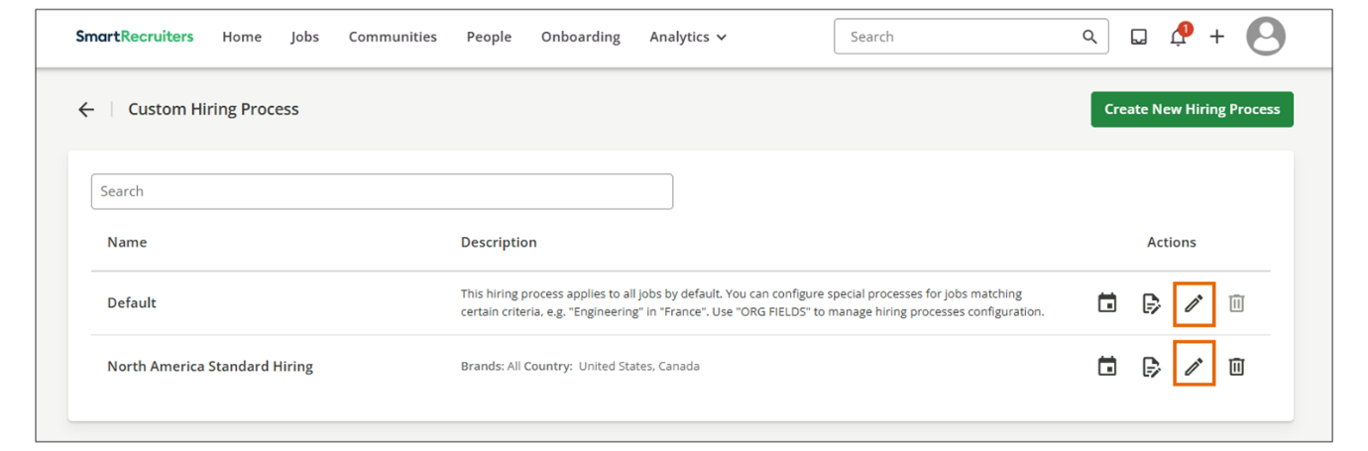
- Select the step you want to add a workflow to, then select Workflows from the dropdown list. On the next screen, you will see the preset workflow step gallery on the left and the workflow you want to configure for this hiring process on the right side.
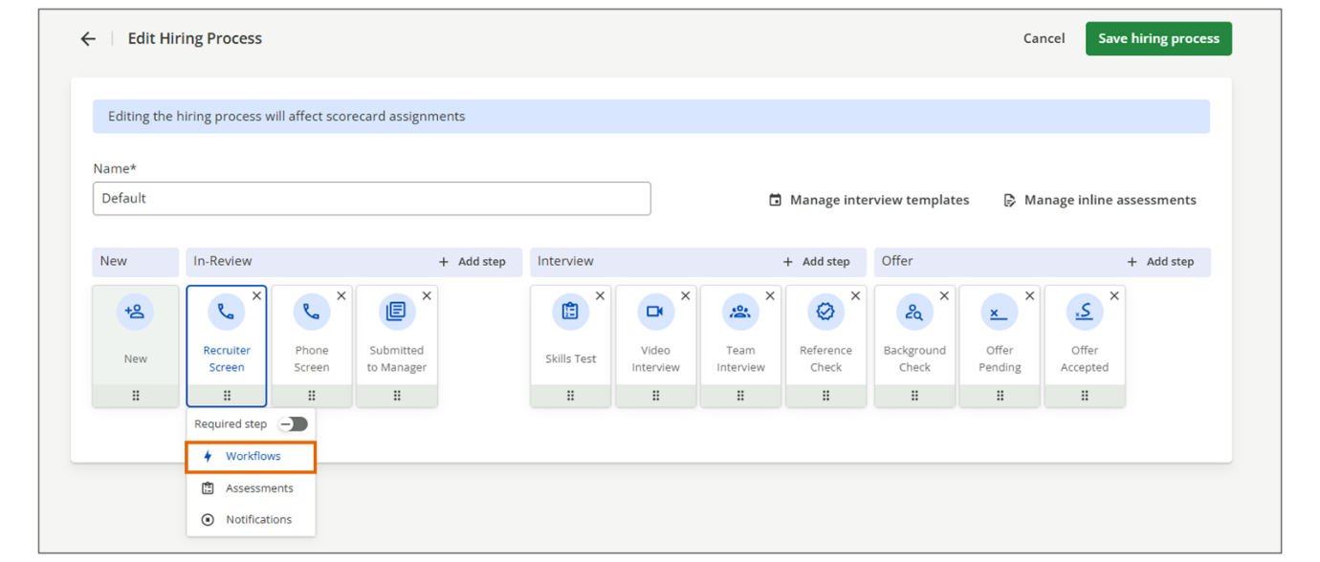
- Drag and drop the chosen workflow steps from the left panel into the workflow builder screen on the right. You can add up to 20 workflow rules of the same type within a single workflow.
- Adjust the workflow properties as needed. These differ per workflow rule.
- Remember to select Save if you edit workflow properties.
Use Case Example: Streamlining Internal Mobility for Company A's IT Department
Company A wants to encourage internal mobility and recognizes that current employees applying for IT roles don't need the same screening process as external candidates. Their talent acquisition team decides to create a dedicated hiring process for IT positions that efficiently accommodates both internal and external applicants.
The Challenge:
Internal candidates already understand Company A’s culture and have a proven track record, but they are required to complete the same lengthy screening steps as external applicants. This creates unnecessary work and delays for both recruiters and candidates.
The Solution:
To improve efficiency, the team decides that internal employees applying for these roles should skip the initial screening steps and move directly to the Submitted to Manager stage. They achieve this by using the Move Forward workflow in the New status with the condition If the employee badge is yes. As a result, all new internal applicants are automatically advanced to the Submitted to Manager step.
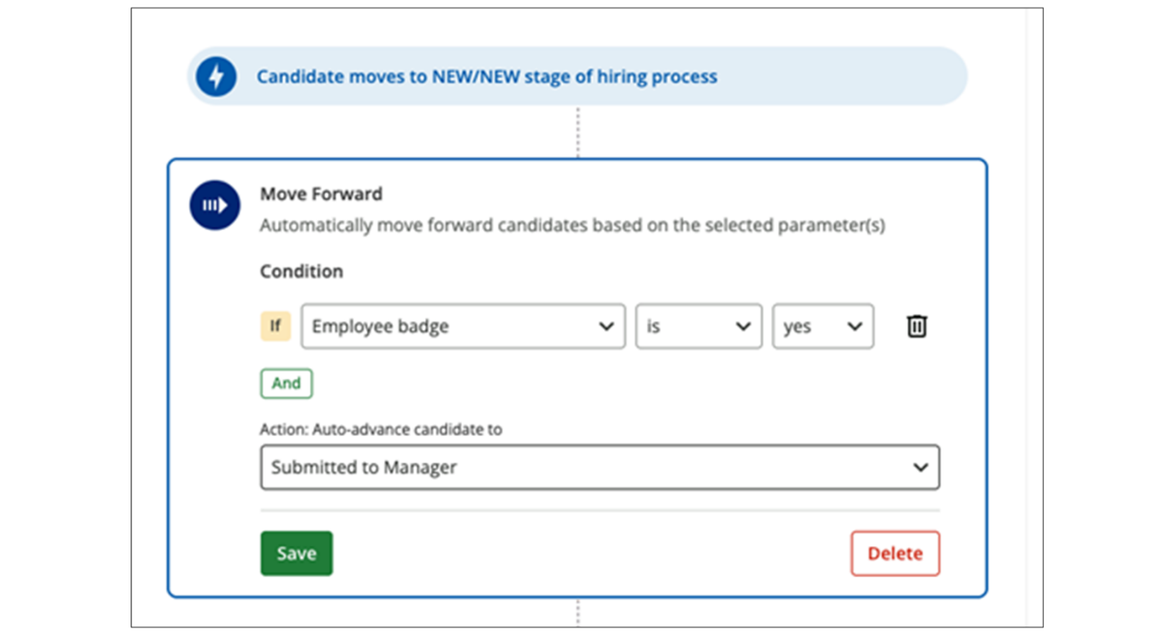
Privacy Considerations
The current feature may be considered automated profiling or decision-making under applicable data protection laws. There, SmartRecruiters recommends reviewing the privacy and legal implications of this feature with your legal and/or privacy teams before activating it.
SmartRecruiters, as a data processor, does not determine how data is processed; it processes its customers' data in accordance with the instructions in the data protection addendum.
In this case, you have complied with applicable data protection regulations and taken the steps required prior to activating this feature. SmartRecruiters cannot be held responsible for any claims and/or requests from customers’ applicants who are impacted by activating the feature.
Watch the video below for more details about configuring hiring process workflows.
This video is for demonstration purposes. Any references made in this video to previous or later videos in this course (including titles, numbers, links, or sequence) may differ from the current course structure. Additionally, some functionalities shown may have evolved over time due to ongoing enhancements or business decisions.
Summary
- Workflow rules in SmartRecruiters automate tasks and enforce consistency within the hiring process.
- Standard workflow rules include actions such as coordinating interviews, sending self-schedule links, collecting interview feedback, and rejecting candidates.
- Automated workflow rules include moving candidates forward, sending messages, auto self-scheduling, auto-rejecting candidates, and inviting candidates to hiring events.
- Workflows are configured against a hiring process step and applied to all jobs or applications associated with that step.
- Each step in the workflow includes properties such as filter rules, actions, owners, and SLA.
in this video we're going to be
looking at how to add workflows assessments or notifications to
the different steps in your hiring process. Within a hiring process
you'll see as I click on the different steps in the stages here, I have
a pop-up that's giving me some options. Any of the steps under In-Review, interview, or Offer can be marked Required, meaning that the
candidate cannot move forward within the hiring process until they
have reached this step. The step cannot be skipped, so I can set
that here if I'd like to make this a required step. I also have options
here to add workflows to steps. If we have any third-party integrations
with assessment vendors that we've set up through our marketplace
and SmartRecruiters, you can assign an assessment to a step as well
and you also can send notifications to members of the hiring team
once a candidate reaches a certain step. So if I click on workflows you'll
see I'll be brought to the workflow page that has all of the steps in
this particular hiring process. And the one different step here
that only gives a couple options in the workflow is the new step.
So you'll see for this step I already have some workflows
configured. One is pipeline cleanup. If I want to add a pipeline cleanup
step to my workflow, what this will do is, if the candidate has been in
the new step for a certain number of days it's going to recreate a
task which is sending a reminder to the hiring manager or other member
of the hiring team to review the candidate and take an action, as
they've been sitting in that step for a few days. You can configure how
many days you want that to be, and the other thing you can do with a
new step workflow is send a message. So here I have the option to send
a message to a team member if a candidate hits this step. I can
choose who that message goes to. I can also choose a named user of
the system, if it's somebody other than someone on the hiring team. And
then I can choose my template for the message that's going
to be sent. These templates are configured in the Custom Email
Notifications area under Templates in the Settings and Admin. And there
you can configure message templates for messages that are sent to
candidates and sent internally. This is an internal message, so it's
only going to show me the templates I have set up for internal
communications here. So I have the one resume review template I'm going to
send. You also have the option to add a filter to this, so maybe send
this a few days after they've been in this step, or if it's zero days
it will be sent immediately once the candidate reaches that step. If
i want to send another message to maybe another member of the hiring
team, I can add another one here. And if for any reason I need to stop
these workflow steps under this step, I can click the disable workflow
button here. What this will do is we'll pause this workflow and it
won't run, but it will keep all of my steps in place, so in the event that
i need to reinstate this workflow or we want to turn it back on, I
can just toggle this back on without having to re-add any of the steps
that I had prior in my workflow. You'll see as I click on
some other steps under In- Review or Interview or Offer,
I'm going to have some more options here as far as
workflow steps are concerned. A couple I'll highlight include
the send self-schedule step, so I'm going to drag this here if I
wanted to add that to my workflow. If you have a calendar integration
with SmartRecruiters, once a candidate reaches this video interview step,
I'm going to assign a task to a user, either a member of the hiring
team or a named user, to let them know to send that candidate an
invite to self-schedule. If you don't have the calendar integration, you
also can use the coordinate interview step as well. And it's very similar
as this will send a task again to a user that I name telling them it's
time to schedule the interview once the candidate has hit this step. If
I were in the Offer stage, I could have a task sent to one of the
hiring team role members to create an offer for this candidate if they
hit say one of the offer steps here. I can also move a candidate forward
based on their star rating so maybe this step would be used closer
to a final interview. And I can say that if this average star rating
after the feedback's been gathered is between whatever I say it is,
maybe between two and five or three and five, that I want to automatically
move this person to a future step in the hiring process. And
then I can choose that here. Also, I can reject a candidate based on
their star rating as well. So if their star rating after the interviews
have taken place are on the lower side between one and three, I can
create a task that will be sent to the hiring team member that I
assigned to reject this candidate. Again, we have pipeline cleanup
like we saw in the new step. We can add that here as well.
We can send a reminder to different members of the hiring
team to submit their feedback after the interviews have taken
place if they have not already. Also, another offer step we can use
if you're using offer approvals, we can send a reminder if certain
approvals are still pending. We can let people know that they
need to take an action on that. We also can have a candidate interview
reminder sent after a certain number of days. So what this will
do is that after a candidate has been in whatever step I'm working
in, in this case the video interview step, for a certain number of days,
I want to create a task to have the member of the hiring team role
send a message to this candidate to remind them to schedule their
interview if they have not done so. And then finally, we have the Send
message option again. Here it looks a little different than in the new
stage because this option actually allows you to send a message to a
candidate as well as internally. So if somebody hits the Video interview
stage and I have a certain email I like being sent out to them. A great
example of this is sometimes when a candidate hits the Resume review,
they come out of New and they go into the Resume review step. If you want
to send them just a small email saying we've received your resume and
it's currently being reviewed, you can have that set up automatically
through this hiring process workflow. So in that case, if I
wanted it to be sent to a candidate, I would choose
candidate as the recipient. And you'll see this will show me
all of the custom email notification templates I've set up that are
meant to be sent to candidates. So you'll see, like I mentioned,
the Under review is here. And then again, you can choose if you
want this sent after a certain number of days. So maybe I don't
want this to be sent until the candidate has been in the step for
a couple days, or I can send it immediately. And then like we
saw in the new step, you can also choose to send a message to a
hiring team role or a named user. And you'll notice if i choose one of
these, it's changed my template options so now, i'm only seeing
my internal facing templates here. Once you've created the workflows
that you want on the particular steps, you can go back to the hiring
process. And you'll know that a step has workflows set up because if there
is a blue icon next to workflows, rather than a gray one, that
means that this step actually has workflows set up for it currently.
The same will apply to assessments or notifications if you set these up
for a step those will also be blue. And quickly assessments; it's very
similar to the inline assessments where if you have a integration
with an assessment partner, and you have it set up and turned on through
our marketplace, they'll show up here. The difference between this
and the inline assessment though, is that you are able to add an assessment
provider ad hoc. You can come in and choose the one you need. You
can save that, and then what you see here will depend on if you
already have a standing contract with this third-party assessment vendor
or if you need to purchase it. And you'll see that some assessments
have the option of auto-triggered. This particular assessment does not
allow for that functionality, but if I was able to toggle this on,
instead of the member of the hiring team getting a notification to send
an assessment manually, once the candidates hit that step. If the
auto-trigger is a functionality that the assessment allows, you can just
have the assessment sent to the candidate directly and automatically
once they hit that step rather than having a member of the hiring
team have to manually send that. And then finally if I go back and
I look at notifications, hybris just a simple toggle and I can
decide whether I have a notification which is a simple notification
email sent to the hiring manager when a candidate reaches this step,
so I'll say yes, and now once I come back you'll see I have a
notification set up this is now blue. Thank you for watching this video
on creating workflows, assessments, and notifications for hiring
process steps in SmartRecruiters.

Creating a Rejection Process
Objective
After completing this lesson, you will be able to configure custom rejection and withdrawal reasons to improve hiring insights.
Rejection and Withdrawal Reasons
Configuring rejection and withdrawal reasons correctly helps you understand why candidates leave the hiring process, improve your recruiting approach, and keep accurate records. In SmartRecruiters, managing these reasons well ensures reliable data and provides valuable insight into how your hiring process is performing.
When a hiring team marks a candidate’s application as rejected or withdrawn, they can select a reason. These reasons help teams understand where candidates are being lost in the hiring process and why decisions are made.
There is an important difference between the two types of reasons:
- Rejection reason: Explains why the hiring team chose not to move forward with a candidate’s application.
- Withdrawal reason: Explains why the candidate chose to withdraw after applying for the role.
When managing rejection and withdrawal reasons, the following settings are available:
- Display SmartRecruiters’ default rejection reasons
- Require a reason when rejecting an application
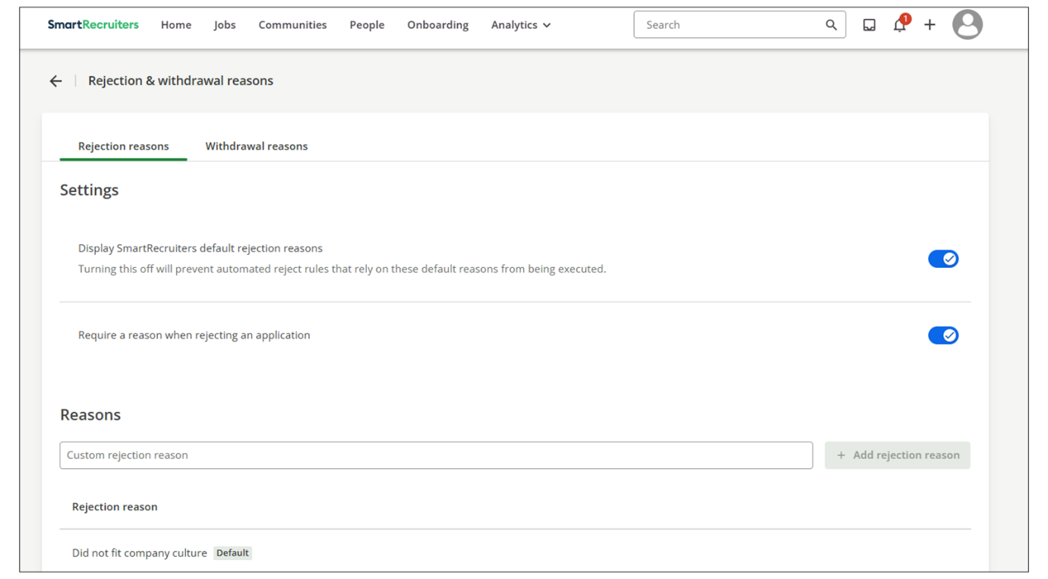
Default Rejection Reasons
SmartRecruiters provides a default list of rejection and withdrawal reasons. The following rejection reasons are available by default and can be turned on or off:
- Did not fit company culture
- Did not meet desired qualifications
- Did not meet minimum qualifications
- Did not meet screening requirements
- Incomplete application
- Ineligible to work in location
- Misrepresented qualifications
- More qualified candidate selected
- No show for interview
- Other
- Unresponsive
Default Withdrawal Reasons
The following withdrawal reasons are available by default and can be turned on or off:
- Took another job
- Compensation
- Personal reasons
- Not willing to relocate
- Commute
- Cultural fit
- Lack of recruiter follow-up
- Confusing job description
- Will stay in current company
- Not interested in the first place
Custom Rejection Reasons
If needed, you can customize the list of rejection reasons to better reflect the specific circumstances of your hiring process. You can add, remove, and update reasons as needed. Furthermore, you can require users to select a reason when rejecting or withdrawing a candidate, ensuring consistent data collection.
Add a Custom Rejection Reason
Steps
- Navigate to Settings.
- In the Configuration section, select Rejection & withdrawal reasons.
- Select the tab Rejection reasons to create a new rejection reason.
- In the Custom rejection reason field, enter the name of your custom reason.
- Select Add rejection reason.
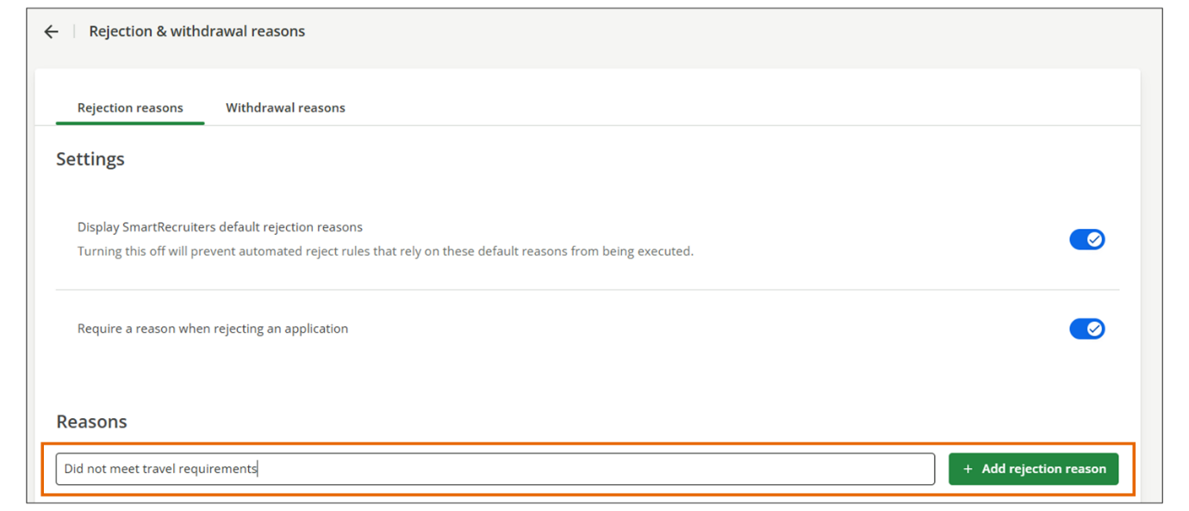
- Repeat the same process to create custom withdrawal reasons, but this time from within the Withdrawal reasons tab.
Use Case Example: Improving Company B's Candidate Experience Through Custom Rejection Reasons
Company B has been using SmartRecruiters for 6 months and has noticed a pattern in their quarterly recruitment reports: a high number of candidates are being rejected with the generic reason Other, making it difficult to identify specific bottlenecks in their hiring process.
The Challenge:
The Talent Acquisition (TA) Director reviews the data and realizes they can't answer key questions:
- Are candidates being rejected due to scheduling conflicts?
- Is compensation misalignment a recurring issue?
- Are certain positions attracting unqualified applicants due to unclear job descriptions?
Without specific rejection data, Company B can't pinpoint where to improve its recruitment process or candidate experience.
The Solution:
The Admin team analyzes feedback from recruiters and hiring managers and decides to create custom rejection and withdrawal reasons that reflect Company B's specific challenges.
Custom Rejection Reasons Added:
- Scheduling conflicts - unable to accommodate interview times.
- Overqualified for position.
- Lack of retail experience.
- Failed background check.
Custom Withdrawal Reasons Added:
- Accepted position with competitor.
- Interview process too lengthy.
- Relocation assistance not offered.
Additionally, they enabled the Require a reason when rejecting an application setting, ensuring consistent data collection across all hiring teams.
The Result:
Three months later, Company B's analytics reveal that 40% of withdrawals cite Interview process too lengthy. Armed with this insight, they streamlined their hiring process from 4 weeks to 2 weeks, significantly improving their offer acceptance rate and candidate experience.
Watch the video below for more details about working with rejection and withdrawal reasons.
This video is for demonstration purposes. Any references made in this video to previous or later videos in this course (including titles, numbers, links, or sequence) may differ from the current course structure. Additionally, some functionalities shown may have evolved over time due to ongoing enhancements or business decisions.
Summary
- Configuring withdrawal reasons is crucial for understanding why candidates drop out of the hiring process and improving your recruitment strategy.
- Rejection reasons explain why the hiring team decided not to proceed with a candidate, while withdrawal reasons describe why the candidate withdrew.
- SmartRecruiters provides a default list of rejection and withdrawal reasons that can be turned on or off.
- You can customize the list of rejection reasons to better reflect the specific circumstances of your hiring process.
- You can require users to select a reason when rejecting or withdrawing a candidate, ensuring consistent data collection.
Hi, and welcome to this lesson on
rejection and withdrawal reasons in SmartRecruiters. So if we
have a candidate that we no longer want to proceed with, or if a
candidate contacts us to let us know they're no longer interested in
pursuing this opportunity, then we can reject a candidate. If the
rejection is on our side, and we can then come through and select a reason
for rejection. We can customize this list as needed. So this is
a list of the standard reasons that are available for all customers.
but if you would like to remove these or add additional reasons
we can do this. We can also choose whether or not the reason for
rejection should be required, so the user must complete it before
they're able to mark the candidate as rejected. Exactly the same if
we have to withdraw a candidate so they've contacted us to let us
know they're no longer interested. Again I've got a standard list of
reasons for withdrawal here which I can add to. I can turn these off
and have my own custom list and also I can make this required if I
wish. So we're going to navigate to Settings and Admin, and underneath
Configuration to Rejection and Withdrawal reasons. So at the top of
the screen, the first thing you'll see is whether you want to display the
SmartRecruiter's default rejection reasons. So if you don't want to
use these ones, you can turn them off and then just create your own
custom list. But if you'd like to keep these and you would like to then
add your own reasons in here, then you can come through and type the
reason you'd like to add, and add that in. Any reasons that you add
to this list you can come in and update and remove as required. If
I want to require a reason when rejecting, then I can enable this here.
So when a user rejects a candidate they must complete a rejection reason.
Exactly the same for our reasons for withdrawal, so if I don't want
to use our default withdrawal reasons list here, I can turn this
off and add my own list of reasons. Or I can come through and add in the
reasons that I would like to see in my withdrawal list. And again if
I want to mark this as required, so the user must complete it I can turn
this on. So that ends our lesson on withdrawal and rejection reasons
in SmartRecruiters. Thank y

